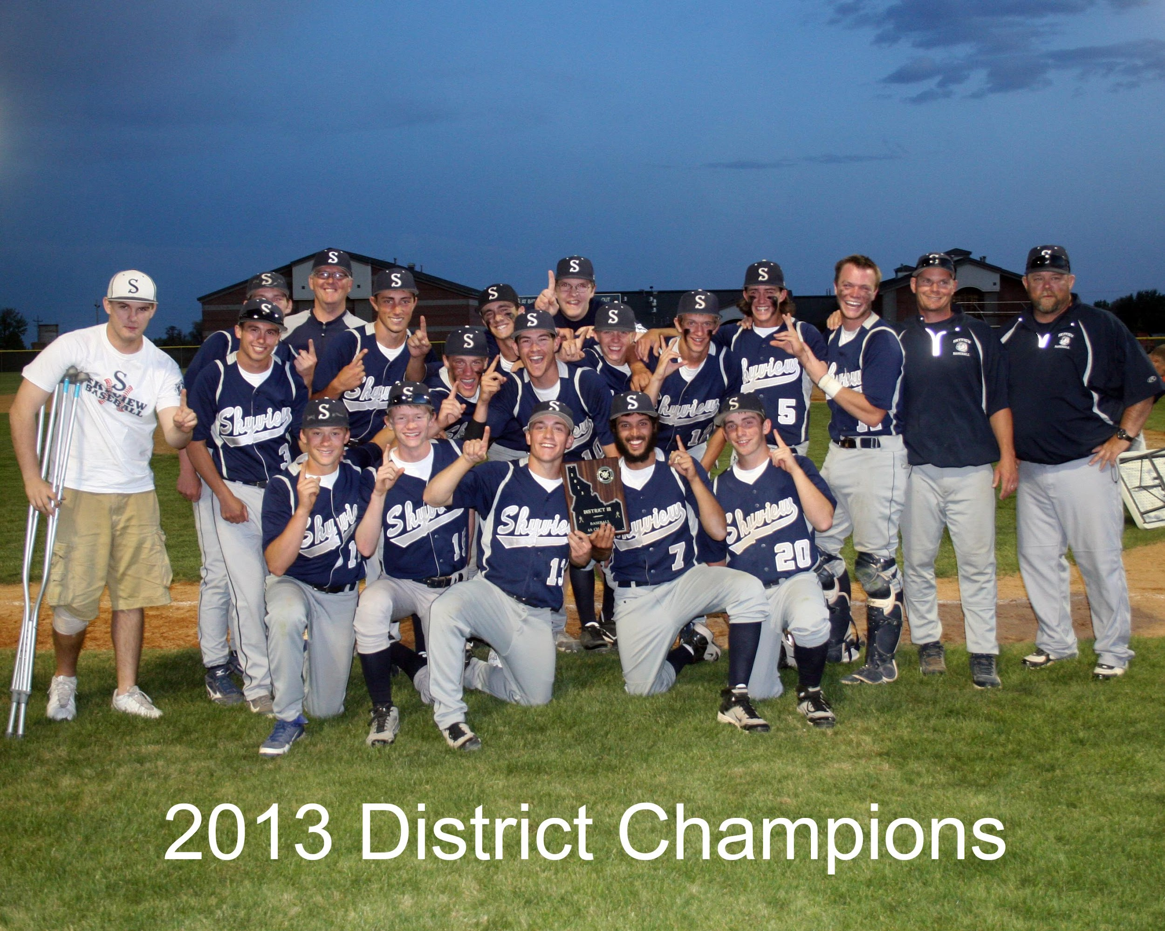
Skyview Hawk Baseball
2014 District Champions
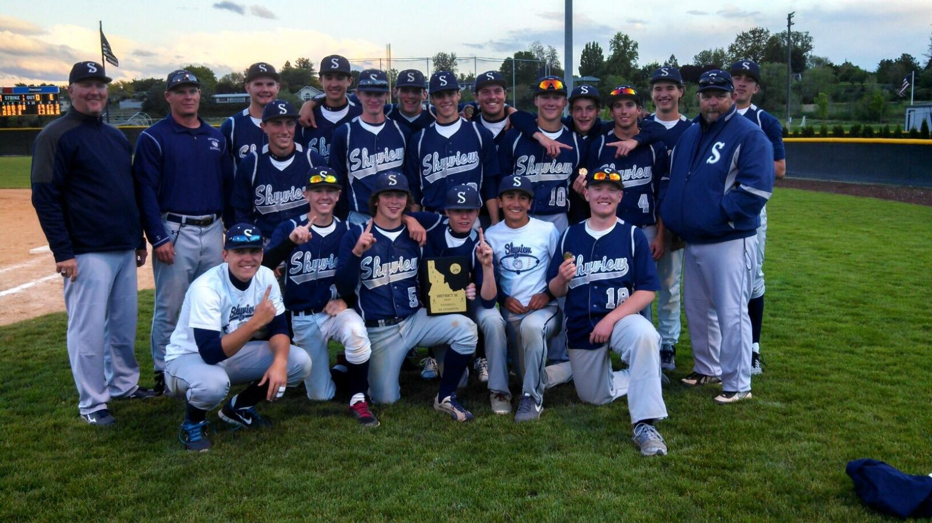
2015, 2017 and 2018 Conference and District Champs
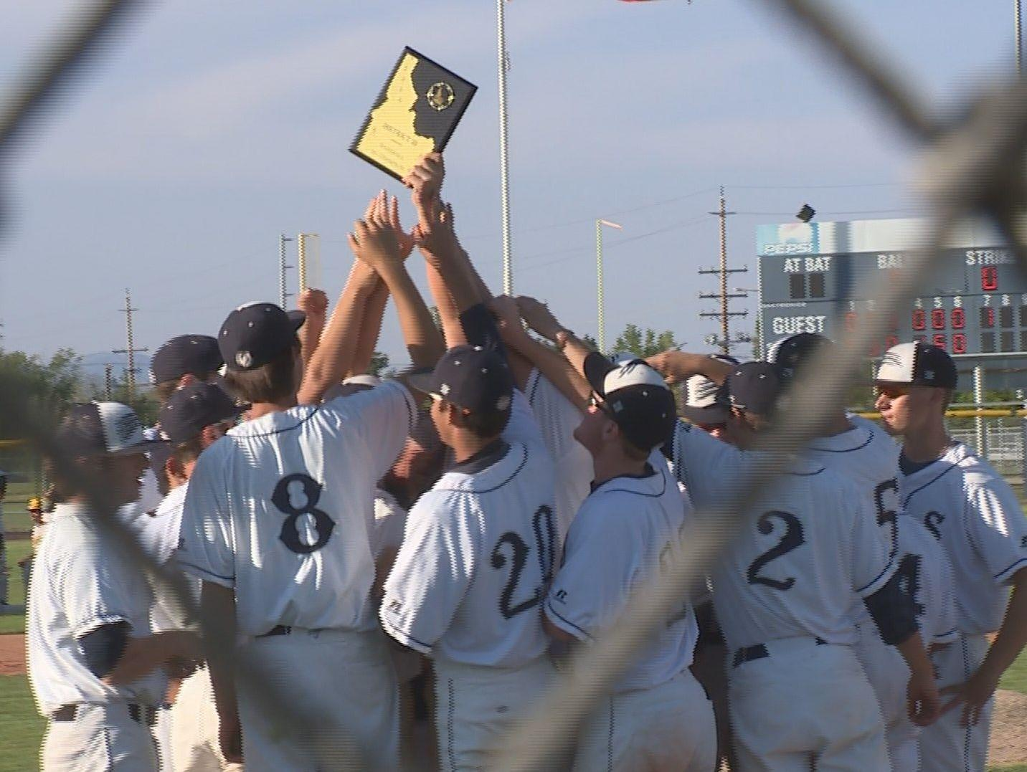
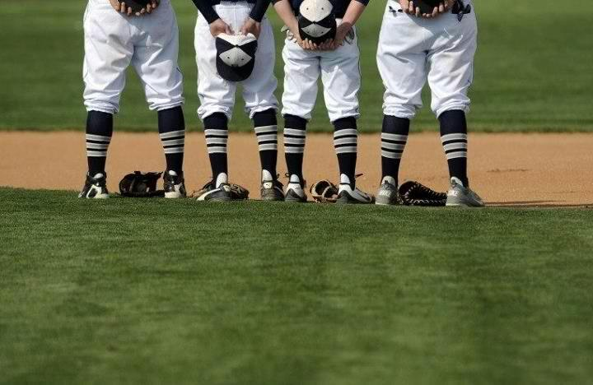

2023
I’m just a ballplayer with one ambition, and that is to give all I’ve got to help my ball club win. I’ve never played any other way.”
~Joe DiMaggio
Skyview Baseball 2023

The coaching staff here at Skyview would like to take the opportunity to introduce ourselves and to outline what we believe is important to building a successful program. Within this packet you will find profiles of each coach in an effort to share a little background on those who are coaching your son. Also, included is some information about our basic philosophy in different aspects of the game. We hope that by sharing our philosophies with each of you we can build a better understanding of the direction we are going. The coaching staff expects to be very competitive year in and year out, we will work and prepare each day in order to reach the high expectations we have for this program.

Ryan Bobo-Head Varsity Coach

Coach Bobo is in his 19th year at Skyview. He is also the Nampa American Legion AA head coach. He comes to Skyview from Buhl High School in Buhl, ID. He was an assistant coach for the 2000 season in which Buhl won the 3A state title. Ryan was head coach at Buhl high school four seasons and the Buhl legion team 3 seasons. He has also assisted at Highland and Century High Schools in Pocatello. Coach Bobo graduated from Pocatello High School and Idaho State University. Coach Bobo teaches U.S. Government and A.P. Psychology. He is married to Tobey and they have one son, Blake (21), two daughters, Aivry (14) and Sydney (7).

Patrick Patterson- Varsity Coach

Coach Patterson is in his 10th season coaching at Skyview. Coach Patterson had a successful college career beginning at Southwest Oregon Community College and later at NNU. He played his high school ball for Wood River High School. Coach Patterson teaches Special Education at Skyview. He is married to Karen.

Joel Nowlin- Varsity Coach

Coach Nowlin is beginning his 7th year at Skyview. . Coach Nowlin played college at College of Idaho and continued to play professionally in leagues all over the world. His experience and knowledge is a great addition to our staff.

Jay Lucas - Varsity Coach

Bio coming soon

Jacob Hoadley- Junior Varsity Head Coach

Coach Hoadley is entering his 12th season with Skyview Baseball. He grew up near Marsing, ID and graduated from Vallivue High School. He attended Albertson College of Idaho and played baseball for two years. He is currently teaching Math and Computer Science at Skyview. He is married to Clela and has two kids, Kennedy and Jordan.

Ryker Loman: JV Asst. Coach

Ryker is beginning his second season with our program. He is a Skyview alum class of 2017. He has worked within the Oakland A’s organization following high school. He currently teaches at East Valley middle school.

2023 Team Goals
- Become better students and baseball players

- Compete on a daily basis

- Win the City Championship

- Win the Buck’s Bags Tournament

- Win the Conference Championship

- Win the State Championship

2023 Skyview Baseball Team Rules
Rules are for those who cannot discipline themselves. I believe each and every one of you is capable of self-discipline. Therefore, a great number of rules are not necessary. However, it is always good to know what is expected. What is expected is that you do the best you can as an individual for the benefit of the team. Your actions and effort should always be for the good of the team. There is no one bigger than the team or the game. Respect the game, your coaches, your teammates, yourself and great things will happen. With that in mind, here are a few guidelines/expectations to follow:

- Any player who is caught using alcohol/drugs will be dismissed immediately. Upon meeting with parents and players, a support system will be developed and the possibility of reinstatement at the decision of Coach Bobo and Skyview administration. (Most unlikely)
- Do not miss practice. If you must miss for any reason you should contact a coach BEFORE practice or you can call me, (308-6317). If you have two unexcused (by a coach) absences, you will be dismissed. Any and all missed practices excused or not, will result in disciplinary actions and/or loss of playing time.
- Do not be late. Get to the field, take care of your assignments and get ready on time. 10 minutes early is 5 minutes late!!!
- Respect your coaches and teammates. We are a team that must play together and respect each other. Baseball is a special game that few people can play well. Treat the game with respect and your teammates like family. This includes equipment, do not throw equipment. You will be suspended for one game if equipment is not taken care of. Bounce rule is in effect.
- In an effort to solve problems and disputes in the most efficient manner the coaching staff will not discuss playing time or decisions that were made during a game with parents/fans immediately after a game. There is a process to handle disputes and grievances, and it does not include confronting each other after a game. Consequences for any such confrontation are that the player will be suspended two games and the offending party will not be allowed to attend those two games.
- Finally, in order to participate in extracurricular activities, I firmly believe that students should at least achieve “average” success in the classroom with a 2.5 GPA. This means those players must maintain a “C” in every class in order to remain eligible. If a player fails to maintain a “C” then a mandatory study hall will take effect. We will provide as much help as possible to improve student grades. Consequences will be determined on a case by case basis. Everyday attendance will be monitored and unexcused absences from school will result in loss of playing time and/or dismissal from the team.

Prepare and play hard each day. Your effort reflects the type of person you are. Put forth the effort to be a champion. Let’s have a great season!

“Baseball gives every American both a chance to excel, not just to be as good as someone else but to be better than someone else. This is the nature of man and the name of the Game.” ~Ted Williams

2023 Skyview Hawks

In order to kick off a new season and to focus our objectives, the coaching staff would like to provide you with what is expected. Obviously, our goal is to win a state championship, district championship, and city championship. These goals are not accomplished without a lot of hard work and believing in our philosophy. The game of baseball is full of intricate details, but we will start by outlining our main philosophy in the three main physical areas; Pitching, Defense and Offense.
Defensive Philosophy: We will stay out of multiple run innings. We will do this by minimizing the number of bases we allow. We will always make good decisions to get outs when the opportunity presents itself.
I firmly believe teams which play solid defense are teams that win a lot of games. We do not have to be “great”. However, we must be fundamentally sound and we must not give “opponents” extra opportunities. Defensively everyone must know what is expected of them and what their role is in every situation. We must be aggressive, while at the same time limiting mistakes. As a coaching staff we will make a promise to each of you that you will not be “chewed out” for fielding errors as long as you are fundamentally sound in your effort. There are too many factors which can create fielding errors. However, as a coaching staff we will not tolerate throwing errors. We play catch everyday, therefore we should be great. We would rather you take the extra time to set your feet and make a good throw. Good throws minimize the number of bases we give up, giving us the best opportunity to win!

Pitching Philosophy: Pitchers will command the strike zone with at least two pitches and not give up walks. Pitchers will work quickly and aggressively. Pitchers will get ahead in the count and will be expected to pitch shutdown innings. Pitchers will be able to field their positions and pitchers are responsible for the running game.

Our pitching philosophy lies in the fact that hitters cannot hit when they are off balance and that pitchers must not walk batters. We must be able to throw strikes with two pitches which will keep the batter off-balance. It is also important that we hit our spots and learn to expand the strike zone to give us an added advantage. If pitchers can continually throw the ball three inches off the plate the umpire will give you that pitch. Around 75% of all walks at the high school level end up scoring, that is unacceptable. Walks give us no chance to get an out, thereby reducing our chance of winning. By working quickly pitchers keep the defensive players in the game mentally and physically. Working aggressively not only means attacking hitters early in the count, throwing first pitch strikes, but also means having an “attitude”. The great pitches have a persona about them which intimidates hitters. Believe in your “stuff”, and better yet, make hitters fear your stuff. This does not mean you have to be a power pitcher. Intimidate hitters by getting ahead and keeping them off-balance. If you can frustrate the opponents, you have won. Part of creating this “persona” includes pitching “shutdown innings”. This means we expect our pitchers to shut down our opponents in the next half inning after we have scored. This allows us to gain momentum and discourages our opponents. Pitchers also must be able to field their position, as well as control the opponents running game by mixing up their delivery and varying their picks (do not become predictable).
Offense Philosophy: We will continually put pressure on our opponents. We will be mentally and physically prepared to take advantage of any situation. We will be aggressive in our base running, while at the same time being smart. We will be good situational hitters. We will force the opponents to change their game in order to defend us.
Not every team can win games with the three-run homer. However, every team can be an aggressive offensive team. We will work on the techniques that allow us to force opponents into giving up extra bases. Once on base we need to have an understanding of when to steal or when not to steal. We should always score from second on a base hit. That comes from working on our leads and recognizing where and how the ball is hit. We must become very good at the early, straight, and delayed steal. Everyone is expected to be able to bunt a runner in scoring position, hit and run, hit behind runners, lift a sac fly in order to advance a runner, squeeze, execute any of our bunts, and understand game situations and how they can best help us win. If we can make teams change the way they normally play the game, then we increase our chances of winning. If we can pressure pitchers to fall behind in the court, we allow our hitters a better chance of having success. If we communicate with each other, relaying signs, acknowledging signs, and reading each other's body language we will force opponents to actively try to stop us, instead of cruising through the game.
As far as the mental part of the game, I would have to write a book to cover even a small part, but this is for starters:
Mental Philosophy: We will always be aware of the situation and be prepared to react to any change in the situation. We will continually learn from our experiences, coaches, teammates, and opponents. We will become students of the game.
There are always opportunities to improve. Great players use everything surrounding them to improve. We can learn as much from watching, listening, and thinking as we can from actually doing a task. We should always be “in the game” and be ready to perform when asked to. Being part of a team also requires players to understand that each player has certain roles which help the team, as a whole, become the best we can. Each player should understand their roles and do their best regardless of what their role may be. Roles may change game to game (and within a game) and a player may change their role through performance, approach to practice, demonstrating a team first attitude, and becoming an intelligent baseball player to complement their physical play. We can only succeed if each player understands and is willing to fulfill their roles, whatever they may be, and whenever they are asked to fill them, to their greatest ability. Everyday players, starting pitchers, relief pitchers, bench players, and situational players are all instrumental to the success of our team.

Master Plan
Team  Defense | Pitchers | Catchers | Infielders | Outfielders | Team Offense | Hitting
Pregame  Infield | 1st pitch strikes | Signs  Blocking | Play Catch | Head hunt  Drop steps | Early Steal | Progression drills
2 fungo drills | Daily warm up | Throwing | Relay Comm. | Correct shoulder | Delay steal  Fake | Power V. Contact
Run-downs  Cutoffs/Double relays  Bunt Defense  1st and 3rd Defense  Pickoffs  Defending the Squeeze  Defending the Safety Squeeze  Coordinate battery with rest of defense  Fall Ball Communication  Defensive Positioning  Multi purpose drills  Relaying Signs: IF to OF | Bullpens  LHP Picks  RHP picks  Non-verbal comm.  Verbal Comm.  Mental approach  Concealing pitches  Effective count approach  Pregame warmup  Relief Prep  Widening the plate  PFP  Progression  Therabands | Bunt Foot/glove work  Force at Home  1.9 to 2nd  Bullpens  Stances  IF Picks  Receiving  Tag plays  Fly Balls  Fungo Blocking  Duck Walk  Calling Game  Manage Pitchers  Read Hitters | Relay technique  Tag plays  Deeks  Holding runners  Slow rollers  3 zone GB  Catch position  Sun Ball  Fence FB  Around the horn  DP’s  Quick Catch  Charge Now!  Backdoor plays  GB to Left side  GB to Right side | Run through ball  Sun FB  Deeks  1-2-3 GB  Throw in front  BP  Angles  Decleat every pitch  Counting Runs  Play the Count  FB circus  Backing up  Fence drills | Steal  Leads  See a move  Jump V. LHP  Jump V. RHP  Ball out of hand  Break up DP  UCLA  Read catcher  Base Circuit  Steals  Base Coach  Contact play  Hit/run  Run/hit  2nd & 3rd Off,  Signs | Positive count theory  Hit/Run  Run/Hit  Bases Loaded  Bunting  Situational hitting  Stations  Two Strikes  Pick signs
The above chart serves as a checklist for us as we install our program and helps to ensure everyone is on the same page.
SKYVIEW HAWKS BASEBALL 2023

PITCHING PRINCIPLES

"My pitching philosophy is simple - keep the ball way from the bat. Just take the ball and throw it where you want to. Throw strikes. Home plate don't move."
~Satchel Paige
Beginnings
- As a team we must first learn to give the utmost respect to this game, to our school, and most importantly to each other.
- We must learn to always respect our teammates. We must hold ourselves accountable for our own actions. We will not “point the finger” or talk badly about our program behind our backs. Chemistry is our initial goal.
- We will learn “the basics” for winning. Discipline, Sacrifice, Desire, Teamwork, Commitment, and Development of Character.

As pitchers we will use the following goals and implement the following techniques to achieve long term success as a program:

- Implement scouting reports into game situations. We will have scouting report on hitters, if not before the game, after the 1st time through the line up. Pitchers and catchers will be able to evaluate stance/swing in hitters and pitch them accordingly. EX: step in the bucket, recognize long swings, etc.
- We must accept that we will have to pitch on the black but will still challenge the zone with most hitters. Never walk the bottom of the order.
- Spend extensive time with catchers to create chemistry with communication. Catchers will learn blocking techniques and receiving. Catchers intangibles: Check swings, reading hitters tendencies. Pressure to become leaders.

Monday Meetings- Pitchers/Catchers
- Evaluate Prior Week
- Learn Mental Game. Pitching in Situations. 0-2, 1-2, 2-2 is an action count- we don’t want full counts.
- When to use off speed vs. waste pitches (6’’ out w/ FB)
- Off speed after 4th inning
- Never, ever get beat 0-2. Good use of 6’’ out, 3’’ in
- Must throw in. We will throw in more than any team we will play. Toughest thing to learn for pitchers/ catchers.
- Teach shake sign for FB
- Scouting report for upcoming games.
- At this level there are usually a small number of hitters that will hurt you consistently. Don’t get beat by them.

Long Term Goal: State Championship

Skyview Baseball will have pitchers, not throwers. We will have great chemistry between pitchers, catchers, and coaches. We will have an extensive scouting report on opposing hitters. We will be better prepared than our opposition; our catchers will know how to implement a game plan. Our pitchers will challenge and compete by attacking the hitter's weaknesses using our strengths.

Pitchers will possess the intangibles that win tough ball games:

- Holding runners, slide step
- PFP’s. Know bunt defenses, get sure outs.
- Will show no emotion on the bump. Keep emotions in check. Will display intimidating mound presence and throw “shutdown” innings!
- All pitchers will throw sinkers
- Will take pride in mechanics/conditioning

Bottom Line

Pitchers that can throw strikes to spots
Pitchers that can make in-game adjustments
Pitchers that display good mound presence
Pitchers that work with our catcher with a game plan
Pitchers that take pride in conditioning
Pitchers that take care of their arm………. Will Pitch for Skyview in ‘23.

If your work ethic doesn’t give us an opportunity to win a ball game, someone with a higher work rate will get the ball, regardless of stuff. Velocity on a fastball is not high on the priority list when determining who will make up our staff. Location, intelligence, and competitiveness will determine who gets innings.

Before the season begins all pitchers provide the following to Coach Bobo and Coach Nowlin:
Pitching folder: Includes: Goal Sheets- Recognize Strengths, Build Weaknesses
Pitching Tendencies- Mechanics, Physical Attributes (Stuff) Intangibles

All pitchers in our program must have the following: Surgical Tubing/J-bands, towel

All pitchers will utilize the following conditioning techniques: Medicine Ball, J-Bands, Plyometrics, and Weighted Balls

